National University of Lesotho
Department of Mathematics and Computer Science
CS4433 Software Engineering - Final Individual Project
Moderated Learning Management System
Phase 1: Project Management Plan
Feasibility study • Work breakdown and schedule • Risk register
Author: Hapile Manyeli
Student number: 202002241
Program: B.Sc Mathematics & Computer Science
Version: 1.0 - baseline at end of Week 1
Date: 4 October 2026
Repository: https://github.com/Selene1203/CS4433-High-School-LMS-project-Manyeli-Hapile

1. Introduction and scope
This document is the project management plan for my CS4433 final project: a Moderated Learning Management System (LMS) for a secondary school. The system will be written in C++17 with SQLite, and the project follows the Waterfall model with V-Model verification and validation over seven weeks.
The plan covers exactly what Phase 1 of the assignment asks for: (1) a feasibility study - whether this project is actually doable, and on what conditions; (2) a work breakdown structure and schedule - what work exists, how long each piece takes, and what the critical path is; and (3) a risk register - what could go wrong, how bad it would be, and what I will do about it.
This document will become Section 3 of the final report. The risk register will be re-issued (updated) at the end of each phase.
In scope (from the brief): user accounts with role-based access for four roles (administrator, lecturer, Head of Department, student); courses, enrolment and assignments; submission, resubmission, late penalties and extensions; marking, moderation, release of marks, and an audit log recording every mark change.
Out of scope (from the brief): online payment, video conferencing, automated grading, plagiarism detection, and web or mobile interfaces.

Planning assumptions
- A1. I can work 35 hours per week (5 working days × 7 hours). Weekends are not scheduled and are kept as contingency.
- A2. The supervisor can review each gate artefact within one working day of submission.
- A3. Data volume is roughly 800 students × 8 courses × 10 assignments ≈ 64,000 submissions per year. This is an estimate to be confirmed during requirements.
- A4. v1.0 is a console application installed on one school computer.

2. Feasibility study
I assessed the project against the five feasibility dimensions from the brief. Summary first, justification after.
Dimension | Verdict | Main condition
Technical | Feasible | Database file stays on one host (no network share)
Operational | Feasible with conditions | Role-based menus; manual per role
Economic | Feasible | No licence or hardware cost; effort is the cost
Legal | Feasible with conditions | Minimise and protect learners' data
Schedule | Feasible, tight | Strict MoSCoW scope control; weekly checkpoints
Table 1: Feasibility summary

2.1 Technical feasibility
Every tool required by the brief is free: the C++17 compiler, CMake, SQLite, GoogleTest, cppcheck/clang-tidy and Git. The Week 1 repository already builds with GCC and passes its smoke tests, so toolchain risk is already retired. SQLite supports any number of simultaneous readers and one writer at a time; writers queue because locks last only milliseconds (SQLite, n.d.-a). A workload of about 64,000 submissions per year (A3) is trivial for it.
The main technical question is the “local network” wording in the brief. SQLite itself warns that file locking on some network filesystems is unreliable and can corrupt the database, and recommends a client/server database when the data is separated from the application by a network (SQLite, n.d.-b). My interpretation: the database file lives on one host and every session runs on that host, so remote users connect by terminal session rather than by sharing the file. I will raise this as a requirements ambiguity at Gate 1 to be sure.

2.2 Operational feasibility
The Principal wants a system teachers can use without IT expertise, and the IT officer needs it to work offline on old computers. A console application with short menus - where each user only sees the actions their role allows - and no network dependency satisfies both. The moderation step (the HoD checks marks before release) matches an existing school responsibility, so it introduces no new role. The condition is usability support: a user manual per role and an installation guide a school technician can follow are planned deliverables of Phase 7.

2.3 Economic feasibility
There is no cash outlay. All tools are free or open source, SQLite is in the public domain, and the software must run on the school's existing computers. The real cost is my development effort: 195 hours baseline against 245 hours of capacity, leaving 50 hours of contingency (Section 3). Running costs are limited to a technician's installation time and routine database backups.
The benefits: less manual collation of marks, late penalties applied the same way every time, and an auditable record of who changed a mark and why. I considered adopting an existing web-based LMS and rejected it: it needs a server stack and a web interface, which conflicts with the offline requirement and the out-of-scope list, and it would not meet the learning outcomes of this module.

2.4 Legal feasibility
The system holds personal data about learners, many of whom are minors. Lesotho's Data Protection Act 2012 requires collection for specified purposes (s.18), limits retention (s.19), requires appropriate security safeguards (s.20) and makes special provision for children's data (s.36) (Lesotho, 2012). My design response: store only what the process needs (name, username, role, enrolment, marks, feedback), enforce role-based access, store only salted password hashes, keep an audit log, and give the administrator a documented retention and deletion procedure. Third-party licences (SQLite, GoogleTest, and whichever password-hashing library I choose) all permit this use. Section 11 of the final report covers these issues in full.

2.5 Schedule feasibility
The deadline is fixed at seven weeks and there is one developer (me). The critical path is 35 working days - the entire schedule - so there is no float on it (Section 4). Baseline effort is 195 hours against 245 hours of capacity, and the busiest week stays within the 35-hour assumption after levelling. The plan is achievable, but only with disciplined scope control and early warning of slippage.

2.6 Recommendation
Proceed, subject to four conditions:
- C1. v1.0 runs on a single host that owns the SQLite file; confirm this at Gate 1.
- C2. Requirements are prioritised with MoSCoW; Could/Should items are dropped before any Must item slips.
- C3. A weekly checkpoint compares progress with the Gantt chart. If slippage on the critical path reaches two working days, the plan is revised immediately and the supervisor is told.
- C4. Assumption A1 (35 h/week) is checked at each checkpoint; if capacity falls, scope is reduced rather than quality.

3. Work breakdown structure
The work decomposes into the nine phases from the brief plus a project-control branch: 33 scheduled work packages and one recurring package (weekly checkpoints). Each work package has a single deliverable, an elapsed duration in working days, and an effort estimate in hours. Figure 1 shows the schedule; Table 2 is the WBS dictionary.
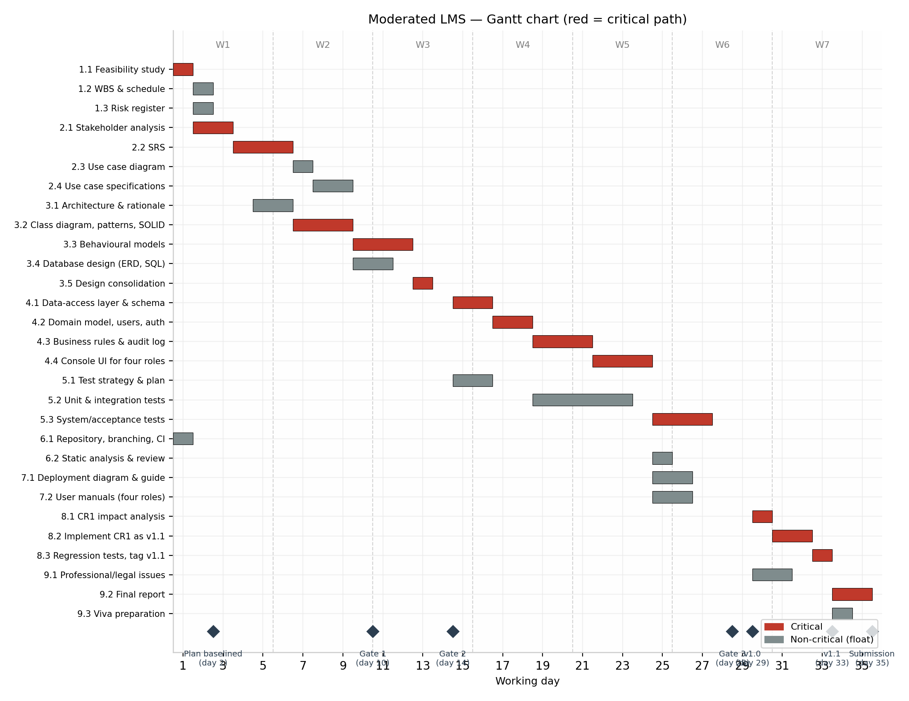
Figure 1: Gantt chart of the 35-working-day schedule (dashed lines mark week boundaries; milestones shown as diamonds)

3.1 Critical path
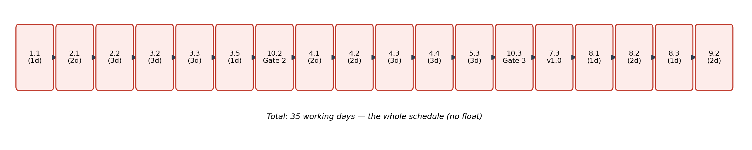
Figure 2: The critical path - 35 working days, the whole schedule (no float)
Activities off this path have float, but levelling used up the float of 2.3, 2.4 and 3.1, and 3.4 and 9.3 have only one day left, so a slip in any of these five becomes critical immediately.

Table 2 - WBS dictionary
Durations in working days (d); effort in hours (h).
WBS | Work package | Duration | Effort (h)
1 | Planning and management |  | 11
1.1 | Feasibility study | 1 d | 4
1.2 | Work breakdown and schedule | 1 d | 4
1.3 | Risk register | 1 d | 3
2 | Requirements engineering |  | 25
2.1 | Stakeholder analysis and conflicts | 2 d | 6
2.2 | Software requirements specification | 3 d | 10
2.3 | Use case diagram | 1 d | 3
2.4 | Use case specifications | 2 d | 6
3 | System design |  | 35
3.1 | Architecture and rationale | 2 d | 6
3.2 | Class diagram, patterns, SOLID | 3 d | 10
3.3 | Behavioural models | 3 d | 9
3.4 | Database design (ERD, SQL) | 2 d | 7
3.5 | Design consolidation | 1 d | 3
4 | Implementation |  | 35
4.1 | Data-access layer and schema | 2 d | 7
4.2 | Domain model, users, authentication | 2 d | 7
4.3 | Business rules and audit log | 3 d | 12
4.4 | Console UI for four roles | 3 d | 9
5 | Verification and validation |  | 27
5.1 | Test strategy and plan | 2 d | 5
5.2 | Unit and integration tests | 5 d | 14
5.3 | System/acceptance tests, defect log | 3 d | 8
6 | Configuration management and QA |  | 10
6.1 | Repository, branching and CI | 1 d | 5
6.2 | Static analysis, metrics, code review | 1 d | 5
7 | Deployment |  | 10
7.1 | Deployment diagram, install guide | 2 d | 4
7.2 | User manuals (four roles) | 2 d | 4
7.3 | Release notes, tag v1.0 | 1 d | 2
8 | Maintenance |  | 10
8.1 | CR1 classification, impact analysis | 1 d | 3
8.2 | Implement CR1 as v1.1 | 2 d | 4
8.3 | Regression tests, tag v1.1 | 1 d | 3
9 | Completion |  | 19
9.1 | Professional, legal, ethical issues | 2 d | 5
9.2 | Final report, traceability, references | 2 d | 10
9.3 | Viva preparation and demo rehearsal | 1 d | 4
10 | Project control |  | 13
10.1 | Gate 1 review (requirements) | 1 d | 2
10.2 | Gate 2 review (design) | 1 d | 2
10.3 | Gate 3 review (V&V) | 1 d | 2
10.4 | Weekly checkpoints (7 × 1 h) | recurring | 7
 | Baseline effort |  | 195
 | Capacity (7 weeks × 35 h) |  | 245
 | Contingency within capacity |  | 50

4. Schedule
Activities are scheduled in working days (five per week, 35 in total) with finish-to-start dependencies. The critical path was computed with the critical path method by the script gen_plan.py in the repository, which also generates the figures and tables, so the diagram and the numbers cannot disagree. Durations are elapsed days; effort in hours is separate (Table 2). Phase overlaps follow the brief: requirements (weeks 1–2), design (2–3), implementation (4–5), verification (5–6), deployment (6), maintenance and completion (7). Implementation cannot start before Gate 2 passes, and the schedule enforces this.

4.1 Schedule with float
Durations and start/end are working-day numbers; float is remaining after resource levelling.
WBS | Activity | Dur | Preceded by | Start | End | Float | Critical
6.1 | Repository, branching and CI | 1 | - | 1 | 1 | 13 | No
1.1 | Feasibility study | 1 | - | 1 | 1 | 0 | Yes
1.3 | Risk register | 1 | 1.1 | 2 | 2 | 10 | No
1.2 | Work breakdown and schedule | 1 | 1.1 | 2 | 2 | 10 | No
2.1 | Stakeholder analysis and conflicts | 2 | 1.1 | 2 | 3 | 0 | Yes
2.2 | Software requirements specification | 3 | 2.1 | 4 | 6 | 0 | Yes
3.1 | Architecture and rationale | 2 | 2.1 | 5 | 6 | 0 | No
2.3 | Use case diagram | 1 | 2.1 | 7 | 7 | 0 | No
3.2 | Class diagram, patterns, SOLID | 3 | 3.1, 2.2 | 7 | 9 | 0 | Yes
2.4 | Use case specifications | 2 | 2.2, 2.3 | 8 | 9 | 0 | No
10.1 | Gate 1 review (requirements) | 1 | 2.2, 2.4, 1.2, 1.3 | 10 | 10 | 3 | No
3.4 | Database design (ERD, SQL) | 2 | 3.2 | 10 | 11 | 1 | No
3.3 | Behavioural models | 3 | 3.2, 2.4 | 10 | 12 | 0 | Yes
3.5 | Design consolidation | 1 | 3.4, 3.3 | 13 | 13 | 0 | Yes
10.2 | Gate 2 review (design) | 1 | 3.5, 10.1 | 14 | 14 | 0 | Yes
4.1 | Data-access layer and schema | 2 | 10.2, 6.1 | 15 | 16 | 0 | Yes
5.1 | Test strategy and plan | 2 | 10.2 | 15 | 16 | 6 | No
4.2 | Domain model, users, authentication | 2 | 4.1 | 17 | 18 | 0 | Yes
4.3 | Business rules and audit log | 3 | 4.2 | 19 | 21 | 0 | Yes
5.2 | Unit and integration tests | 5 | 4.2, 5.1 | 19 | 23 | 4 | No
4.4 | Console UI for four roles | 3 | 4.3 | 22 | 24 | 0 | Yes
6.2 | Static analysis, metrics, code review | 1 | 4.4 | 25 | 25 | 2 | No
7.1 | Deployment diagram, install guide | 2 | 4.4 | 25 | 26 | 2 | No
7.2 | User manuals (four roles) | 2 | 4.4 | 25 | 26 | 2 | No
5.3 | System/acceptance tests, defect log | 3 | 4.4, 5.1 | 25 | 27 | 0 | Yes
10.3 | Gate 3 review (V&V) | 1 | 5.2, 5.3, 6.2 | 28 | 28 | 0 | Yes
7.3 | Release notes, tag v1.0 | 1 | 10.3, 7.1, 7.2 | 29 | 29 | 0 | Yes
8.1 | CR1 classification, impact analysis | 1 | 7.3 | 30 | 30 | 0 | Yes
9.1 | Professional, legal, ethical issues | 2 | 7.3 | 30 | 31 | 2 | No
8.2 | Implement CR1 as v1.1 | 2 | 8.1 | 31 | 32 | 0 | Yes
8.3 | Regression tests, tag v1.1 | 1 | 8.2 | 33 | 33 | 0 | Yes
9.3 | Viva preparation and demo rehearsal | 1 | 8.3 | 34 | 34 | 1 | No
9.2 | Final report, traceability, references | 2 | 8.3, 9.1 | 34 | 35 | 0 | Yes

4.2 Milestones and phase gates
Milestone | Day | Week | Exit criterion
Plan baselined | 2 | 1 | This plan complete and submitted
Gate 1 | 10 | 2 | Stakeholder analysis, SRS and use case model reviewed
Gate 2 | 14 | 3 | Design reviewed; implementation may begin
Gate 3 | 28 | 6 | Test results, coverage and defect log reviewed
Release v1.0 | 29 | 6 | Tagged release with install guide and manuals
Release v1.1 | 33 | 7 | CR1 implemented, regression suite passes
Submission | 35 | 7 | Report PDF and repository link submitted

4.3 Resource loading
Spreading each activity's effort evenly over its days gives the weekly load in Table 3. The first pass put 38.7 hours into Week 1 because requirements and design overlap, so I delayed two non-critical activities within their float (use case diagram by three days, architecture by one day); after that no week exceeds the capacity in A1. The lighter Weeks 3, 6 and 7 are the practical contingency, together with the unscheduled weekends.
Week | Load (h) | Capacity (h) | Spare (h) | Status
Week 1 | 32.7 | 35 | +2.3 | within capacity
Week 2 | 34.8 | 35 | +0.2 | within capacity
Week 3 | 21.5 | 35 | +13.5 | within capacity
Week 4 | 27.6 | 35 | +7.4 | within capacity
Week 5 | 34.1 | 35 | +0.9 | within capacity
Week 6 | 19.8 | 35 | +15.2 | within capacity
Week 7 | 24.5 | 35 | +10.5 | within capacity
Table 3: Weekly effort load against capacity

5. Risk management
Each risk is scored for likelihood (L) and impact (I) on a scale of 1 (very low) to 5 (very high). Exposure is L × I, the standard measure of risk exposure (Boehm, 1991). Exposure of 15 or more is rated High, 8–14 Medium and 7 or less Low. The register has 12 risks (3 High, 6 Medium, 3 Low) in three categories: technical, project and people. The highest exposures are the schedule itself (R01) and scope creep (R02), which is why Section 2 makes scope control and weekly checkpoints conditions of proceeding.
ID | Category | Risk | L | I | Exp. | Rating | Mitigation / response | Owner
R01 | Project | Seven-week schedule with one developer and no critical-path float; any slip delays submission | 4 | 5 | 20 | High | Weekly checkpoints; 2-day slip triggers re-plan (C3); MoSCoW scope cuts before deadline moves (C2); weekends as reserve | Student
R02 | Project | Scope creep - extra features requested beyond the brief (reports, notifications, GUI) | 4 | 4 | 16 | High | Strict MoSCoW at Gate 1; out-of-scope list in SRS; changes only via change control after baselining | Student + supervisor
R03 | Technical | SQLite file shared over a network folder corrupts data (“local network” ambiguity) | 3 | 5 | 15 | High | Single-host deployment (C1); raise ambiguity at Gate 1; document for technician: never share the DB file | Student
R04 | Technical | Late-penalty/moderation business rules more complex than estimated, eating implementation time | 3 | 4 | 12 | Medium | Penalty rules as Strategy pattern; unit tests per rule early; rules prototyped in Week 4 spike | Student
R05 | Technical | Password hashing library choice causes build/CI problems on old school machines | 2 | 4 | 8 | Medium | Choose library in Week 3 design; verify it builds with both CI compilers early | Student
R06 | Project | Gate reviews delayed (supervisor availability), blocking implementation start | 2 | 4 | 8 | Medium | Submit artefacts a day early (A2); schedule gates at week's start; escalate after 1 day | Student + supervisor
R07 | Project | Overlapping requirements and design overloads Week 1–2 (first pass showed 38.7 h) | 3 | 3 | 9 | Medium | Resource levelling within float (done); protect Week 3 slack as buffer | Student
R08 | People | Illness or personal emergencies reduce the 35 h/week assumption | 2 | 5 | 10 | Medium | C4: reduce scope, not quality; weekend reserve; tell supervisor early | Student
R09 | People | Loss of motivation late in the project (report writing phase) | 3 | 3 | 9 | Medium | Small weekly wins visible on Gantt; final report drafted section-by-section from Week 5 | Student
R10 | Technical | Test coverage below the 70% target for business logic | 3 | 3 | 9 | Medium | Write tests alongside code (5.2 overlaps implementation); measure coverage in CI from Week 4 | Student
R11 | Technical | Data loss or schema migration problems during CR1 (v1.1) | 2 | 3 | 6 | Low | Backups before migration; migration script tested on copy; regression suite as safety net | Student
R12 | Project | Toolchain breaks mid-project (CMake/compiler updates, CI runner images) | 1 | 4 | 4 | Low | Pin CI runner versions; repository builds from Week 1; docs list exact versions | Student
Table 4: Risk register (baseline, Week 1)
The register is reviewed at every weekly checkpoint and re-issued at each phase gate.

6. Project control
Configuration management. Source and documents live in one Git repository. Work is done on short-lived branches merged into main by pull request, and every gate and release is tagged (gate-1, gate-2, gate-3, v1.0, v1.1). A GitHub Actions pipeline builds the project with two compilers, runs the tests and runs cppcheck on every push. The rules are in docs/branching-strategy.md.
Progress control. A weekly checkpoint compares actual progress with the Gantt chart and updates the risk register if any exposure has changed. Slippage of two working days on the critical path triggers re-planning (condition C3).
Change control. After a gate, a baselined artefact changes only through a pull request that states the reason and updates the traceability matrix, which links each functional requirement to its use case, design elements, source files and test cases.

References
Boehm, B.W. (1991) 'Software risk management: principles and practices', IEEE Software, 8(1), pp. 32–41.
Lesotho (2012) Data Protection Act, 2012 (Act No. 5 of 2012). Available at: https://lesotholii.org/akn/ls/act/2012/5/eng@2012-02-22 (Accessed: 4 October 2026).
SQLite (n.d.-a) Appropriate uses for SQLite. Available at: https://www.sqlite.org/whentouse.html (Accessed: 4 October 2026).
SQLite (n.d.-b) SQLite over a network, caveats and considerations. Available at: https://www.sqlite.org/useovernet.html (Accessed: 4 October 2026).

